System Record Sheet
Installer |  | End-Customer
 | Name
 | Str./No.
 | Postcode/Town
Telephone/Mail
(Landline and Mobile)

Wholesaler
Part-No.:
Serial-No.:
Installation-Date |  | Commissioning Date

Installation
- Batterie-Type  (e.g. RESU 10H; RESU 6.5) |  | - Inverter-Type
- Back-up function? |  | - Software-Versions(s) (Inverter)
- Battery voltage  measured (at battery pack!) | __________V | - Inverter serial number
- Hast he battery ever been recharged manually? If so, how low was the voltage? |  | - Only high voltage batteries: Do you have an black auxialiary switch or a 2-pole switch?

- Error description
- Error codes (from inverter)

Has the system been previously operating? (has it charged/discharged?) | YES / NO
Is the internal circuit breaker able to be turned ON & OFF? | YES / NO
Do the battery LED lights illuminate? | YES / NO
Is the Warning or Fault LED light on? | YES / NO
Does the inverter recognize the battery BMS? | YES / NO
What is the fault code indication on the inverter screen?
Is AC-grid and inverter energy meter correctly installed to the inverter? (correct direction as well?) | YES / NO
If you have already done the online test, what is the certificate number?
Does the battery show any swelling? (If YES, then send please photos!) | YES / NO

- Battery-Type: e.g. RESU10H-R or RESU 6.4EX.
- Inverter Type: e.g. SMA Sunny Boy Storage or Solar Edge, etc.

- Back-up function used? (Yes/No)

- Software-version(s) of the inverter.

- Measured battery voltage:

- High voltage batteries (RESU 7H/10H):
  - 1. Remove the black top cover
  - 2. Disconnect the connection to the DC/DC converter
  - 3. Measure directly at the connection terminal from the battery pack

- Low-voltage batteries (RESU 3.3/6.5/10/6.4EX):
  - 1. Please switch the circuit breaker into the OFF position
  - 2. Switch the circuit breaker into the ON position
  - 3. Measure the voltage at the connection terminal of the battery

- Serial number of the inverter, maybe for later requests at the inverter-support

- Is the system connected to the internet? (inverter-portal?)

- For high voltage batteries Type-R (for SolarEdge, Fronius, Huawei) exists two different types: The first has a black auxiliary switch below the 5-pole main circuit breaker. The second one has a 2-pole circuit breaker.

- Please fill in all battery-related error codes!

- Please fill in a detailed error description!

General Checklist:
- If the Fault/Warning LED is active, check all power and communication cabling!
- Check the voltage of the battery pack and compare it with the minimum voltage from the installation manual!
- If you have communication problems with a low-voltage battery, please check the DIP and rotary switches! (e.g. the DIP and rotary switches have another setting with a Solar Edge inverter)
- If you have a RESU-Plus box the DIP switch from the box must be set to 0011 and from the two batteries to 0010.
- If you leave a high-voltage battery a longer time without operation, please switch the main circuit breaker first to the OFF position and second the AUX-switch(!) to the OFF position. This is to avoid a deep discharge.
- Please never change the AUX-switch when the main circuit breaker is active!

Information to find the correct serial number:
For further processing we always need the correct serial number. Please have a look to the following examples where you can find them!

RESU 6.4EX / 3.2:
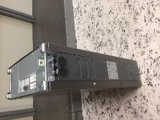
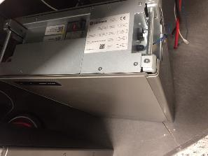

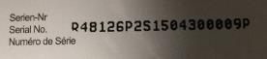
Example S/N:

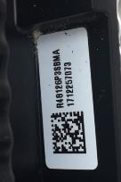
RESU 3.3 / 6.5 / 10 / 13:
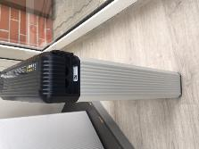

Example S/N:

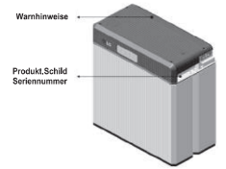
RESU 10M:

RESU 7H / 10H:
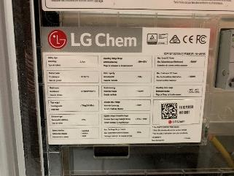
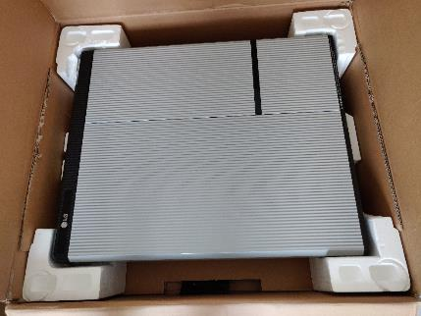

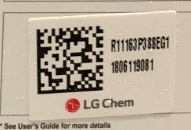

Measurement at high voltage batteries:
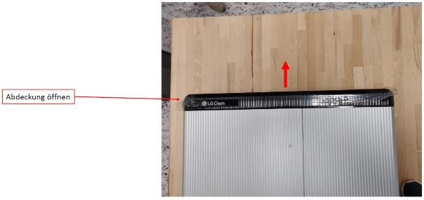
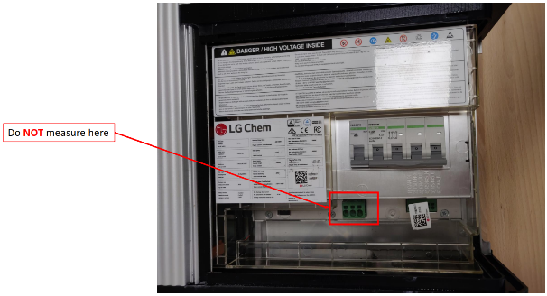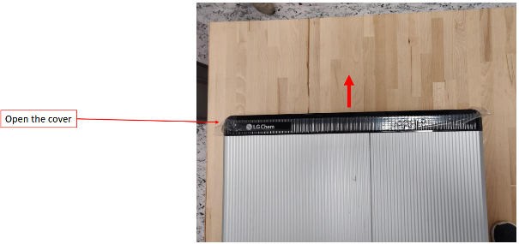
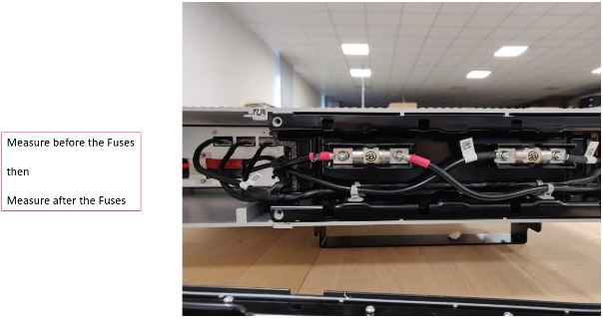

If you have the new model with only one fuse below the top cover, please measure at the following points:

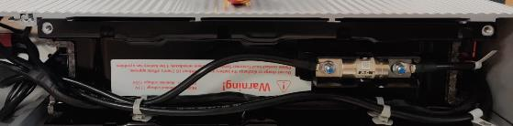

Measure at these points with the negative terminal of your measuring device. Please measure before and after the fuses to check if the fuse is not defective.

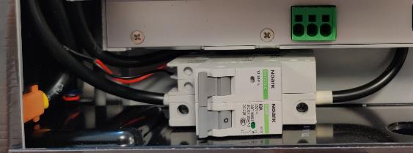
Please measure at this point with the positive terminal of your measuring device.

